“The Ilminsterian” - Vol.XX No.38

Autumn Term 1927, Spring and Summer Terms 1928

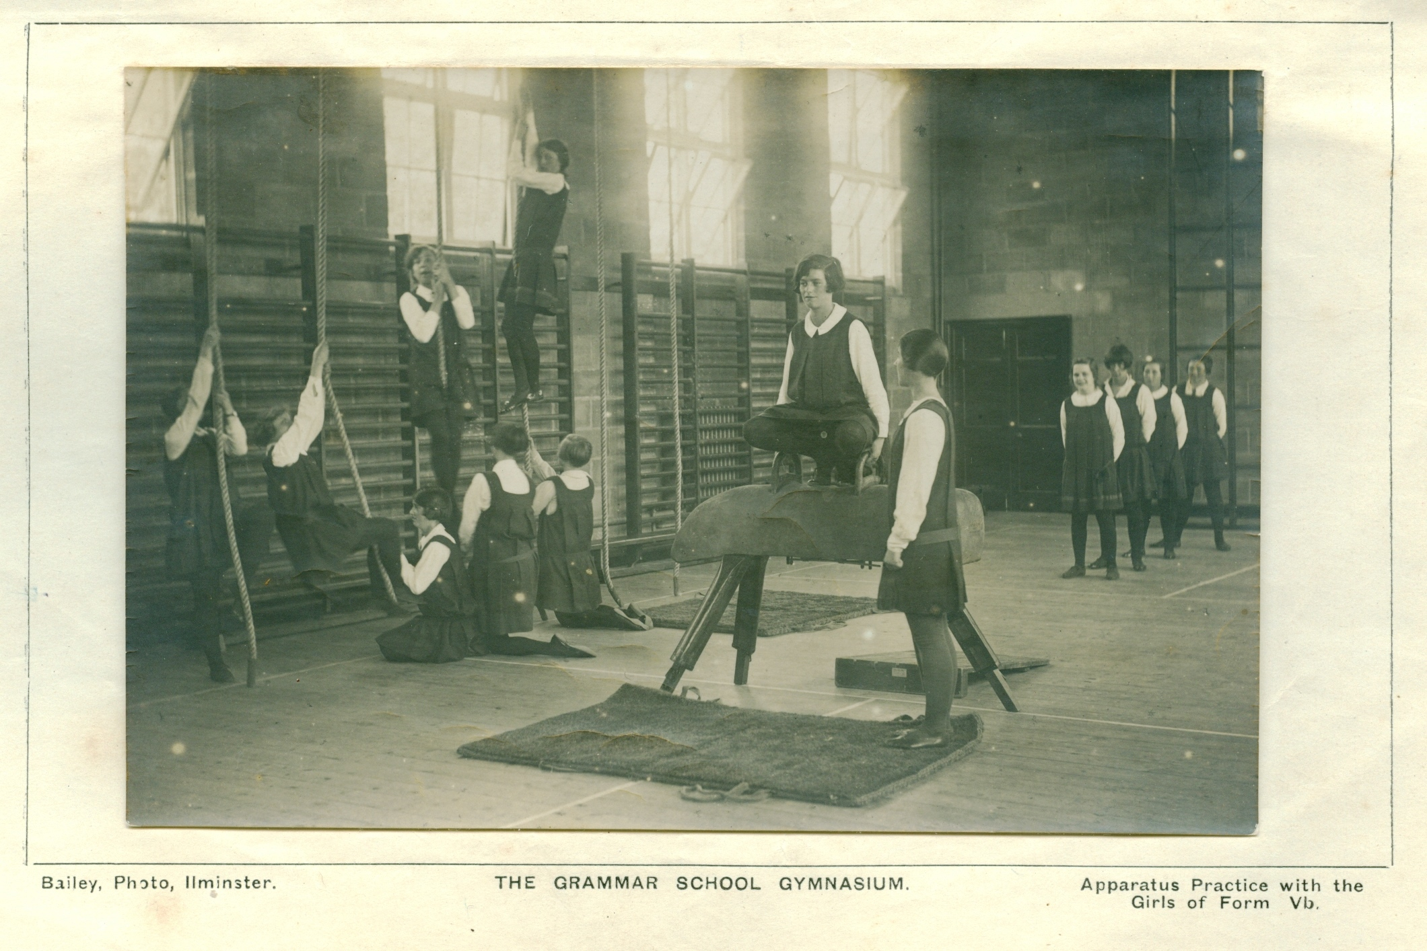
THE GIRLS' GRAMMAR SCHOOL - HISTORIC GLEANINGS 1928
The coming `Jubilee' celebrations of the Girls' Grammar School necessarily turn our thoughts to its early days, and a few notes on past events will be of interest to many of the present pupils, and to the many `Old Girls' who take our annual magazine.
As far back as February 1874, the Governors of the Endowed School for Boys were discussing plans for "converting the present school buildings into a Town School for Boys and Girls with residences for the Master and Mistress", and considering that the earliest Girls' High Schools in the country were established in 1872, Ilminster was well in the van in educational matters, as Ilminsterians will be gratified to note.
That the inclusion of girls under the scheme should be properly sponsored it was also resolved to invite Lady Anna Gore Langton and Mrs. Caroline Speke to become the first Lady Governors, and the invitation was accepted, these ladies' names appearing frequently thereafter, in the lists of " Governors Present."
During the next two years discussions centered round financial considerations, plans and specifications, the purchase of a site, appeals to the Charity Commissioners for their consent to the expenditure necessary, and the possibility of obtaining further private support, if the Endowment fund became insufficient-the idea may have been to float a "Girls' High School Company " as other towns did at the time-but matters came to a deadlock when the only site and plans the Charity Commissioners would sanction proved to be so expensive that the Governors protested "but if the school is built at that cost, there will be no funds left to carry it on" !
Eventually it was decided that the whole scheme should be remodeled, that a new building should be erected for the Boys on the north end of the field which they already had as a playing field, on the South side of the Church, and that the old building should be adapted for a Girls' School.
This plan was authorized by the Charity Commissioners, and in September of 1878 the notice occurs "alterations for the Girls' Grammar School are well in hand, the front wall of the Eastern gable is being rebuilt" and in November "a covered way is suggested leading from the house to the large school-room". The boys had evidently moved to their new buildings-but that covered way did not materialize till 1880.
They were leisurely days, and more delays occurred, so that the school did not actually open for pupils until April 28th, 1879, but it has always been reckoned an 1878 foundation, since it became "The Girls' School" in the latter half of that year.
Concerning the choice of the first Head Mistress, a very modern note was struck in the decision the Governors made to interview Miss Mosey and a certain Mrs. Cockett, "provided she has not a husband".
Miss Mosey was however appointed, and to her was delegated the appointment of assistant mistresses, whose total salary should not exceed £87. The fees of the school were graded for age, £3 to £5 5s. a year, and the Boarding
fees were £40, exclusive of school fees. A Lunch room fee of seven shillings a term was allowed and pupils provided their own books and stationery.
Mrs. Speke had already resigned, and Lady Anna Gore Langton died early in March 1879, so that actually there were no Lady Governors when the school opened, but in 1882 Mrs. Baker and Mrs. Brookes were appointed, and since then the Governing body has always included some lady representatives.
From an " Old Girl " of that period we hear that the second term was started with a staff of three teachers including the Head mistress, Miss Bowes and Miss Calvert being the second and third class teachers, and that Dr. Ham, now organist at Toronto Cathedral, was the music master.
An increase of forty pounds in the allowance for assistant mistresses in the next year indicates the appointment of a third assistant, and an increase in numbers in the school.
Further structural improvements were also made; in 1880 the upper court was asphalted, and the next year a bath with cold water `pipe was fitted into the small room over the porch, quite a luxury in those days!
From Miss Harding a teacher in the school in 1881, we hear that the school then numbered sixty pupils, mainly day girls, divided into six classes. A school regulation at that time prevented a girl remaining after the age of sixteen without consent of the governors and the eagerness for education, of the girls of those days is attested by the frequency of those. applications for the permission to remain, " which permission was never refused " says the Governors' minute book.
In April, 1882, the governors decided to allow Foundation Scholarships to girls on the same conditions as to boys, and the first two Foundation Scholars were Amy Taylor and Betty Ullett. Since that date, upwards of seventy girls of outstanding ability have received Foundation Scholarships to assist them in continuing their education.
In 1883, the governors allowed £10 for books to form the nucleus of a library, and the next year they put new windows into the large schoolroom.
In 1884 Miss Mosey resigned her position through ill health to the regret of the Governors, and from another kind informant among the Old Girls, we hear that she died at Dawlish, in 1900.
She was succeeded by Miss Caroline Hairsine of Ballymoney Co. Antrim, under whom the school steadily prospered. In 1886 the Staff and Boarders were allowed the use of the Boys' Playground for tennis two evenings a week, but Miss Hairsine, now Mrs. Hall tells us that much of the necessary exercise took the form of long country rambles made more interesting by the collection of wild flowers. "Our school hours were from 9.0 to 12.0 and from 2.0 to 4.0, with a whole holiday on Saturday," she writes; "but after I had been at the school a short time I started a Kindergarten for children of from three to seven years of age, which was only open from 9.0 to 12.0. 1 think my top number of pupils was eighty, ten of whom were boarders, and two Scholarship girls from the Board School. The first year I was there the three top girls all won distinction in the Oxford Local Senior Examination, and Amy Taylor of Puckington was first in England in Theory of Music. We had our Prize-giving and Concert just before the Summer holidays when the Vicar (the Rev. James Briscoe) gave out the prizes, and just before the Christmas holidays we had three parties, one for the Seniors, one for the Juniors and one for the tinies, which we all enjoyed very much. I think we had generally four weeks holiday at Christmas, three at Easter, and six in the summer, beginning about the end of July.
When I left to be married in Ilminster Church, I had a staff of six mistresses, most of them with University degrees, and one of them, a foreigner, to teach French and German. The music, vocal and instrumental was taught by Dr. Ham; and a visiting dancing mistress, (Miss Benton) came weekly from Taunton."
From another source we hear that Sergeant Fenner taught Drill, weekly, at a charge of 6d. a term for each pupil in the first and third terms of the year.
It is interesting to note the early successes of the Ilminster girls in the Oxford Locals, and to total up the school's attainments since. We find records of eighty-six Junior Cambridge passes, and a hundred and sixty two Senior, one First, five Second, and five 'third Class Junior Honours; one First, six Second, and twenty one Third Class Senior Honours, and since the Cambridge ceased to differentiate the Honours into Classes, in 1923, four girls with honours. So that the school may well look back with gratitude to the three pioneers of 1886.
In April, 1892, Miss Hairsine left to be married to the Rev. H. A. Hall, the ceremony took. place in Ilminster Church, and Mrs. Hall is still living at Eltham Vicarage, her first 'married" home.
She was succeeded by Miss Sumner, who had previously held the position of Head mistress in the Blue School, Wells. Under the new headship, the Science and Art Department recognized Miss Sumner and Miss Walmsley as qualified to earn grants, and classes were held in Drawing and Physiography.
In December, 1892, the first Christ's Hospital Scholarships were offered in the Girls' School and Ethel Mary Prew was the first "Scholar" from Ilminster. Only three girls, Winifred Rowe Christine Harcombe and Olive Slade have followed her example.
Early the next year the first large addition was made to the accommodation of the school, when the room at present used for the Junior Department, was built as a "Technical Kitchen" on the Lower Court, and equipped for the teaching of Cookery and Dressmaking, with a qualified teacher, Miss May Lawrence.
A little later Gymnastic apparatus was fixed up in this same room-but it made it decidedly cramped for use.
In January, 1896, Louise Taylor took the Queen's Prize of £2 2s. Od., for success in Mathematics in the South Kensington Examination, being the seventh of over six hundred First Class Certificate winners.
Examinations were now becoming more important, and in 1898, the Governors decided that in lieu of the school July Examination, they would pay the fees for the girls to take the Cambridge Locals, and that all scholarship girls must take those examinations if required by the Head-mistress.
In spite of these external successes, the numbers in the school were decreasing steadily, insomuch that reduction was made in the staff allowance, and suggestions were made that the staff should receive their salary direct from the Governors.
In December 1900 Miss Sumner resigned and the January term opened with Miss Henley, B.A., as Head mistress, and the addition of a visiting Art Mistress, Miss Stook, from Taunton Art School, for one day a week.
In 1902 a Board of Education Inspector made a very satisfactory report on the school, and the numbers of scholars began to increase again. A. year later two girls passed the London Matriculation and in 1904 Florence Sampson took the first Senior County Scholarship won by an Ilminster girl and tenable at the Bath School of Cookery.
Since then we have had one Senior County Scholar, Phyllis Northcombe, in 1923; one Intermediate County Scholar, Alice Beament, one winner of the Rankine Scholarship of the Somerset County Council, Dorothy Martin, and one State Scholarship and Senior County Scholarship won by Marjorie Baker in 1926, a satisfactory testimony to the continued efficiency of the school.
In 1905 Miss Henley resigned, and was succeeded by Miss Pollard, B.A., Lond., who is still Head Mistress.
Almost immediately she applied for a fully qualified Science Mistress, and the next year Miss Camm, B.Sc., was appointed. Suggestions being made for the school to become a Secondary School under the Board of Education the Governors arranged for several more alterations in structure. The Western school-room was fitted up as a Science Laboratory and two new Junior Class rooms were built on part of Cross House garden, with access through the right hand cupboard of the large schoolroom.
In 1907 a third large classroom was added over the Technical Kitchen, and eventually the school was recognized by the Board of Education as a fully equipped and organized Secondary school and the proposal, first made in 1892, that the Kindergarten should become an integral part of the school was carried out two years later in accordance with the suggestion of the Board's Inspector. The appointment of a fully certificated Kindergarten mistress led to the inclusion of Training for the National Froebel Union Certificates, and five students have obtained part of their training here, two more being trained fully in our Kindergarten.
The question of making Ilminster a Pupil Teachers' centre was also discussed, and it was in 1908 that two of our girls won Pupil Teacher Candidate Scholarships and the first two of our twenty three Bursaries were granted.
The same year saw the appearance of the first number of the `Ilminsterian' under the editorship of Mr. W. P. Martin, and Miss Bell, so that the fiftieth year of the school is the twentieth of the School Magazine and if the more modern part of the School History is shortened somewhat it is with the idea that the many interested in it will already have the full current notes contained in those volumes of the magazine.
In 1909 a Leaving Exhibition was established for the girls similar to the Hanning Exhibition offered in the Grammar School, and to be used in a corresponding manner, that is to enable the candidate to carry on her education in some higher centre of training such as a University.
It was awarded in 1909 to Katherine Bicknell and eighteen girls have since won it, the majority of them having used it to assist them in following a Bristol University Course.
Progress has also been made on the musical side, for while in 1906-7-8 and 9 one pupil each year had obtained a music certificate, 1910 saw three girls taking the Advanced Associated Board Certificate, and since then we have had eighty one successes, one pupil, Dorothy Fardo, obtaining Distinction in the Advanced Examination in 1918. Since leaving us she has completed her L.R.A.M.
In 1912 two girls gained certificates for pianoforte playing in the South Somerset Musical Competition and the Ilminster girls have twice won the Taunton Shield for Choral Singing once in 1923, and again in 1926.
The purchase of a splendid playing field, at the foot of Herne Hill, in 1909, gave a great impetus to the Games of the School-Hockey and Net ball pitches for the Winter, and four tennis courts (later five) for the summer provided ample opportunity for practice for all, and the school has also had the advantage of sharing in the Inter-schools Hockey and Tennis Tournaments. Three times they have been the winning team, in Tennis, bringing home the Silver Rose Bowl which is so hardly fought for, but they have not yet succeeded in being first on the hockey field.
In 1909 the Inter-schools Tennis Tournament was founded and the five schools then competing were Exeter, Bruton, Taunton, Bearninster and Ilminster.
Numbers steadily increased in the school, and so did examination successes. 1913 was the first year of many honours and distinctions, and in December 1915 and December 1916 we had no failures among the thirty five candidates, and in 1917 only one failure out of nineteen entries.
During these years of war, too, the school took its small share in the sacrifices needed. The playing field was used for hay and pasture, the girls resigned their prizes, the money going to the Red Cross Society; Fruit and Vegetables were collected for the Fleet, Eggs for Hospitals and Foxglove leaves for the herbalists; and many members did their part during holidays in V.A.D. or Farm work.
Boarders increased greatly in numbers (partly owing to the war conditions for daily travelling being so inconvenient, and also because the Eastern part of England was more affected by enemy attacks) and a hostel was obtained, which has been given up since normal conditions have been restored.
Work has gone on steadily during the last ten years. Eighty eight of our Senior Cambridge successes belong to that period, and we have had two girls taking the Bristol Higher Certificate, Marjorie Ding and Marjorie Baler-the latter with Distinction in English and French. Our Reference Library which began in 1908 with gifts of books from girls who were leaving now overflows the two large cupboards provided for it by the Governors, and is used incessantly by staff and pupils alike. For some years the Governors have contributed annually to the Book Fund. The Dorcas Society which began in 1907 has sent garments regularly to a very poor school in Camberwell; and by way of interchange Portfolios have been sent to and received from schools in Bermuda, Africa and India. A Junior Red Cross Society was formed, and led by Mrs. Duke for two winters-but in 1925 the girls decided to form a Girl Guides' Company. This is now three patrols strong and is doing good work. The Musical Society has been meeting fortnightly on winter evenings for the last seven years, and is a very popular feature of school life among the senior girls.
In 1924 the Governors built a handsome Pavilion on the playing field, which makes our Sports equipment one of the best in the Western Counties-and just recently they have added to the Girls' School large light airy cloakrooms on the North side of the large schoolroom, which make a considerable difference to the convenience of the girls.
Successes won by our Old Girls too, have been very stimulating to the school. Besides quite a number of B.A. degrees, three B.Sc. degrees have been obtained. One girl won the Gold Medal for Ophthalmic nursing, one has an Art Teacher's Certificate, one an ALA degree for her thesis on the History of Bermuda, the only extant history of the island, and one old girl is a fully qualified doctor having the London M.B: B.S. Another is giving her life as a missionary in West Africa. The school is proud of its old scholars, and hopeful of its present ones.
Fifty years of earnest work is bearing fruit in a school tradition that we hope to keep up, so that the next fifty years may be even more valuable intellectually, and the school may continue its efforts to nurture the type of citizen-character which shall make for a better and more humane world.
We look forward to a large and representative gathering of Old Girls at the Jubilee Meetings in October, and we hope all readers- will help us to make these meetings widely known.
Our best thanks are due to those correspondents who have contributed to the accuracy of this short article by -their reminiscences, and to the Governors for their loan of record books.

“The Ilminsterian” Vol.XX No.38 – Autumn Term 1927, Spring and Summer Terms 1928

